FARM MANAGEMENT SYSTEM

User Story:
As a farmer, farm manager, or system administrator, I want to use a centralized Salesforce-based platform to record and manage farm, crop, farmer, and buyer information. The system should store agricultural data securely and systematically. Users should be able to enter and update farm details, crop production records, and buyer transactions through a user-friendly interface. Validation rules should help prevent incomplete or incorrect entries. Reports and dashboards should provide timely information about farm productivity and sales, supporting informed decisions. Role-based access should protect sensitive information while allowing authorized users to collaborate. The system aims to reduce paperwork, minimize errors, improve efficiency, and support data-driven farm management.

1. INTRODUCTION

1.1 Project Overview :
The Farm Management System (FMS) is a Salesforce-based application developed to digitize and organize agricultural operations. It maintains information about farms, crops, farmers, and buyers in a centralized platform. The system provides structured data entry, validation, record relationships, reports, and dashboards. Farmers and farm managers can use these features to maintain records, monitor crop activities, review sales information, and make decisions based on available data.

1.2 Purpose :
The main purpose of this project is to provide a reliable digital platform for managing agricultural information. The system is intended to:
- Digitize agricultural data management and reduce dependence on paper registers.
- Improve the accuracy, consistency, and accessibility of farm records.
- Organize farm, crop, farmer, and buyer information in one application.
- Use validation and relationships to support correct data entry.
- Provide reports and dashboards for monitoring productivity and transactions.
- Support timely, data-based decisions and improve transparency.

2. IDEATION PHASE

2.1 Problem Statement (Customer Problem Statement Template)
PS-1 – Farmer: Farmers need to maintain farm and crop records, but manual registers can become incomplete, difficult to update, or inaccurate. This can cause frustration and make it harder to find reliable information.
PS-2 – Farm Manager: Farm managers need to monitor productivity and sales, but information stored in separate files and spreadsheets may be delayed or inconsistent. This can make monitoring and planning inefficient.
PS-3 – Buyer: Buyers need current information about crop availability and pricing. When information is not updated regularly or is not available in one place, buyers may be uncertain about the details.
PS-4 – System Admin: System administrators need to manage user access and protect system information. Manually handled access can create a risk of unauthorized access and cause security concerns.

2.2 Empathy Map Canvas
Target Users:
- Farmers
- Farm Managers
- Buyers
- System Administrators
Empathy Analysis
- Think & Feel: Users need accurate, accessible, and timely farm information to complete their tasks confidently.
- Hear: Users may receive feedback and requirements from agricultural officers and other stakeholders.
- See: Users may currently work with registers, paper files, and spreadsheets.
- Say & Do: Users record, update, and review agricultural information as part of their daily work.
- Pain: Data loss, entry errors, scattered information, and reporting delays can make work difficult.
- Gain: A centralized system, organized records, validation, and faster reporting can simplify farm management.

Selected Idea
Salesforce-based Farm Management System.

2.3 Brainstorming
The following ideas were considered for organizing farm information:
- Manual farm records
- Excel-based management
- Web-based system
- Mobile farm app
- Salesforce-based FMS

Selected Idea
Salesforce-based Farm Management System.

3.REQUIREMENT ANALYSIS PHASE

3.1 Customer Journey Map
The customer journey describes the main steps a user follows while working with the system:
- Login to Salesforce using an authorized account.
- Open the Farm Management System application.
- Enter or update farm and crop data.
- Register and maintain farmer and buyer information.
- Generate reports from the available records.
- Review reports and dashboards to analyze results.
- Use the available information to support farm-management decisions.

3.2 Solution Requirements

Functional Requirements
FR-1: User Authentication – The system should allow authorized users to sign in.
FR-2: Farm, Crop, Farmer, Buyer Management – Users should be able to create, view, and update records for the four main objects.
FR-3: Data Entry and Validation – The system should validate required fields and relevant values before saving records.
FR-4: Relationship Mapping – Records should be linked where required to maintain related farm and crop information.
FR-5: Report Generation – Users should be able to create reports using stored records.
FR-6: Dashboard Visualization – The system should present summarized information through dashboard components.
FR-7: User Role Management – Access should be configured according to user profiles, roles, and sharing settings.

Non-Functional Requirements
Usability: The interface should be understandable and easy to navigate using Salesforce Lightning UI.
Security: Profiles, roles, and sharing settings should help protect records and control access.
Reliability: Cloud-based storage should support consistent record availability; backup and recovery depend on the Salesforce environment and configuration.
Performance: Common operations and reports should respond in a timely manner; the source document specifies a target of under three seconds for reports.
Availability: The cloud-hosted application is intended to be accessible when the service and internet connection are available.
Scalability: The design should support adding more farms and users, subject to Salesforce limits and licensing.

3.3 Data Flow Diagram
Data Flow: User → Salesforce UI → Custom Objects (Farm, Crop, Farmer, Buyer) → Validation Rules → Relationships → Reports → Dashboards.
Users enter information through the Salesforce interface. The records are stored in the corresponding custom objects. Validation rules help check entries, and relationships connect related records. Reports retrieve and organize stored information, while dashboards display selected summaries and visualizations.

3.4 Technology Stack
Frontend: Salesforce Lightning UI
Backend: Salesforce Platform
Database: Salesforce Cloud
Automation: Validation Rules
Analytics: Salesforce Reports and Dashboards

4. PROJECT DESIGN PHASE

4.1 Problem–Solution Fit
The project addresses the difficulty of maintaining agricultural records in separate registers and files. The proposed Salesforce-based system brings farm, crop, farmer, and buyer information into a centralized application. Validation supports more consistent data entry, while cloud storage provides a shared location for authorized users. Reports and dashboards help users review available information without manually combining multiple records. These features are intended to reduce administrative effort and support timely analysis.

4.2 Proposed Solution
Problem: Manual maintenance of farm, crop, farmer, and buyer records can lead to errors, data loss, and delays.
Solution: A Salesforce-based Farm Management System with centralized data storage and configured automation.
Innovation: Structured digital records, data-entry validation, relationships, and reporting dashboards.
Impact: The system is intended to improve data accuracy, speed up reporting, and support decision-making for farmers and managers.
Business Model: A digital farm-management and agricultural data-services platform.
Scalability: The cloud-based design can be extended to support additional farms, users, and regions, subject to platform limits and configuration.

4.3 Solution Architecture
The solution is organized into four layers:
- Presentation Layer – Salesforce Lightning UI provides the screens through which users access the application and enter information.
- Application Layer – Validation rules and record relationships support data quality and the organization of application operations.
- Data Layer – Custom objects store Farm, Crop, Farmer, and Buyer records and their fields.
- Analytics Layer – Reports and dashboards summarize stored information for review.

5. PROJECT PLANNING & SCHEDULING

5.1 Project Planning
The project was planned as a sequence of configuration, development, and verification activities:
- Create a Salesforce Developer Org.
- Develop the required custom objects.
- Configure tabs and the Lightning application.
- Create fields and define relationships.
- Configure profiles and roles.
- Create users and sharing rules.
- Develop reports and dashboards.
- Conduct testing and review the configured system.

Product Backlog, Sprint Schedule, and Estimation (4 Marks)
The product backlog organizes the project work into user stories. Each story has a priority and an estimated story-point value.
Sprint | Epic | User Story | Story Points | Priority | Team Members
Sprint-1 | Developer Setup | USN-1: As a system administrator, I want to create and configure a Salesforce developer account so that I can set up and deploy the FMS. | 3 | High | Member1
Sprint-2a | Data Modeling | USN-2: As an admin, I want to create Farm, Crop, Farmer, and Buyer objects with proper relationships so that agricultural data is stored and managed efficiently. | 5 | High | Member2
Sprint-2 | Data Modeling | USN-3: As a staff member, I want tabs and a Lightning App for all farm modules so that I can navigate and perform daily operations. | 5 | High | Member3
Sprint-3 | Automation | USN-4: As a system, I want to validate farm and crop details such as dates, quantities, and mandatory fields so that incorrect or incomplete records are prevented. | 3 | High | Member4
Sprint-3 | Automation | USN-5: As a manager, I want automated flows for crop updates and buyer notifications so that farm operations are processed faster without manual intervention. | 3 | High | Member4
Sprint-4 | Security | USN-6: As an administrator, I want role-based access control for farmers, managers, and buyers so that sensitive farm and transaction data is secure. | 5 | High | Member2
Sprint-5 | Reports | USN-7: As a farm manager, I want reports showing crop yield, sales, and buyer transactions so that I can monitor farm performance and make informed decisions. | 4 | High | Member3
Sprint-6 | Dashboards | USN-8: As a farm manager, I want dashboards showing crop productivity, sales trends, and operational statistics so that I can monitor performance visually. | 4 | Medium | Member4

Project Tracker, Velocity & Burndown Chart: (4 Marks)
The sprint tracker records planned work, completed story points, and release dates. The schedule below retains the dates and values provided in the source document; blank completion and release fields are left blank where no value was supplied.
Sprint | Total Story Points | Duration | Sprint Start Date | Sprint End Date (Planned) | Story Points Completed | Sprint Release Date (Actual)
Sprint-1 | 20 | 6 Days | 03 Sep 2026 | 08 Sep 2026 | 20 | 29 Oct 2022
Sprint-2 | 20 | 6 Days | 09 Sep 2026 | 14 Sep 2026
Sprint-3 | 20 | 6 Days | 15 Sep 2026 | 20 Sep 2026
Sprint-4 | 20 | 6 Days | 23 Sep 2026 | 28 Sep 2026

6. Project Development Phase:

Project Description:
The Farm Management System (FMS) in Salesforce is designed to digitize and streamline agricultural operations. It supports the management of Farm, Crop, Farmer, and Buyer information and provides reports and dashboards to help users review operational data. The development phase consists of configuring the Salesforce environment, creating custom objects and fields, setting up the application interface, managing access, and preparing reports and dashboards.

Milestone 1-Salesforce:

What Is Salesforce?
Salesforce is a cloud-based customer relationship management platform that provides tools for managing information, workflows, and business processes. In this project, the Salesforce platform is used to create a centralized application for agricultural records. Its configuration features allow the project to define objects, fields, relationships, access settings, reports, and dashboards.

Activity1: Creating a Salesforce Developer Org:
A Salesforce Developer Org provides an environment for learning, configuring, and developing Salesforce applications.
- Open the Salesforce Developer signup page.
- Enter the requested registration details, including name, email, role, company, country or region, postal code, and a unique username.
- Submit the signup form and follow the account-verification instructions sent by email.
- Create a password and save the account details securely.
- Open the Salesforce login page.
- Sign in with the registered username and password to access the Salesforce organization.

Milestone 2-Object:

What is an object?
A Salesforce object is similar to a database table. It stores information in fields (columns) and records (rows). Custom objects can be created to represent data specific to an application.
In This Application We Use 4 Custom Objects:
- Farm
- Crop
- Farmer
- Buyer

Activity 1: Create a custom object for Farm:
In Setup, open Object Manager and choose Create → Custom Object. Set the label to Farm, plural label to Farms, and record name to Farm Name with the Text data type. Enable Allow Reports and Track Field History, set the deployment status to Deployed, enable search, and add Notes and Attachments to the default page layout if available. Save the object.

Activity 2: Creation of Crop object:
Open Setup and Object Manager, then create a custom object. Set Label to Crop, Plural Label to Crops, and Record Name to Crop Name with Text as the data type. Enable reporting and search, add Notes and Attachments to the default page layout if available, and save.

Activity 3: Creation of Farmer object:
Create a custom object named Farmer with plural label Farmers and record name Farmer Name (Text). Enable reporting and search, add Notes and Attachments to the default page layout if available, and save.

Activity 4: Creation of Buyer object:
Create a custom object named Buyer with plural label Buyers and record name Buyer Name (Text). Enable reporting and search, add Notes and Attachments to the default page layout if available, and save.

Milestone 3 - Tab: Tab
Tabs in Salesforce provide a way to access objects and other application content. A custom tab makes the records of an object available through the application navigation.

Activity: Creation of Farm tab:
- From Setup, search for Tabs in the Quick Find box and open Tabs.
- Under Custom Object Tabs, click New.
- Select Farm as the object.
- Choose a tab style or icon.
- Keep the remaining default settings, proceed through Next, and save.

Activity: Creation of Crop tab:
- From Setup, search for Tabs in the Quick Find box and open Tabs.
- Under Custom Object Tabs, click New.
- Select Crop as the object.
- Choose a tab style or icon.
- Keep the remaining default settings, proceed through Next, and save.

Activity: Creation of Farmer tab:
- From Setup, search for Tabs in the Quick Find box and open Tabs.
- Under Custom Object Tabs, click New.
- Select Farmer as the object.
- Choose a tab style or icon.
- Keep the remaining default settings, proceed through Next, and save.

Activity: Creation of Buyer tab:
- From Setup, search for Tabs in the Quick Find box and open Tabs.
- Under Custom Object Tabs, click New.
- Select Buyer as the object.
- Choose a tab style or icon.
- Keep the remaining default settings, proceed through Next, and save.

Milestone 4 - Lightning App:

What is an App?
A Salesforce app is a collection of tabs and features grouped together to support a particular work process. It has an application name and a set of navigation items.

Activity 1: Create the Farm Management System app
- From Setup, search for App Manager and open it.
- Click New Lightning App and enter Farm Management System as the app name.
- Keep the default app options and proceed.
- Keep the default utility items and proceed.
- Move Farm, Crop, Farmer, Buyer, Reports, and Dashboards from Available Items to Selected Items.
- Select the System Administrator profile under Available Profiles and save and finish.
- Open the App Launcher, search for Farm Management System, and select the application to verify it.
Note: The App Launcher displays available applications. The app name identifies the currently selected application, and the navigation menu displays the tabs available inside it.

Milestone 5 - Fields and Relationship: What are fields?
Fields in Salesforce are similar to columns in a relational database. They store the values associated with each record.

Activity 1: Creation of fields for the Farm objects:
- Open Setup → Object Manager → Farm → Fields & Relationships, and click New.
- Create a Picklist field named Farm Type with the values Crop, Livestock, and Mixed.
- Create a Picklist field named Soil Quality with the values Organic, Cover Crops, and Composting.
- Create a Picklist field named Irrigation type with the values Sprinkler irrigation, Drip irrigation, and Localized irrigation.
- Create Text fields named Location and Size.
- Create a Master-Detail relationship with the Farmer object, as specified in the project design.

Activity 2: Creation of fields for the Crop objects:
- Create a Text field named Crop Name.
- Create a Date field named Planting Date.
- Create a Date field named Harvest Date.
- Create a Lookup relationship from Crop to Farm.
- Create a Currency field named Actual Yield.
- Create a Number field named Total Acres Harvested, using the configured field length.
- Create a Formula field named Expected Yield per Acre with Currency as the return type.
- Enter the formula as Actual Yield divided by Total Acres Harvested, then save.

Activity 3: Creation of fields for the Farmer objects:
- Create a Phone field named Contact Number.
- Create a Picklist field named State with the values Telangana, Andhra Pradesh, and Tamil Nadu.
- Create a Picklist field named District and enter the applicable district values.
- Create a Picklist field named Village and enter the applicable village values.

Creation of field dependency :
- In the Farmer object, open Fields & Relationships and select Field Dependencies.
- Click New. Set State as the controlling field and District as the dependent field.
- Choose the district values that should be available for each state. For example, the source document gives Telangana – Yadadri Bhongir.
- Save the dependency and use Preview to test that changing the state updates the available district values.

Activity 4: Creation of fields for the Buyer objects:
- Create a Phone field named Contact.
- Create an Email field named Email.
- Create a Text Area field named Address.
- Create a Picklist field named Buyer Type with the values Wholesale and Retail, then save.

Milestone 6- Profile:

What is a profile?
A profile is a collection of settings and permissions that determines what a user can do in Salesforce. It can control object and field permissions, user permissions, tab and app settings, page layouts, record types, and login hours or IP ranges. A profile can be assigned to multiple users, while each user has one profile at a time.

Activity 1: Create a custom profile:
- From Setup, search for Profiles in Quick Find.
- Select the Standard User profile.
- Click Clone.
- Enter Sales Department as the profile name.
- Save the new profile.

Activity 2: Create a custom profile-2:
Create another custom profile named Farm Manager by cloning the Standard User profile. From Setup, search for Profiles, select Standard User, click Clone, enter Farm Manager, and save.

Milestone 7- Role
In Salesforce, roles help determine record visibility within the organization’s hierarchy and support reporting relationships. Access also depends on profiles, sharing settings, and object permissions.

Activity-1 Creation of role
- From Setup, search for Roles and open the role setup page.
- Under the appropriate parent role, choose Add Role.
- Enter Farm Manager as the role label and confirm the role name.
- Save the role.

Milestone 8-User :

What is a user?
A user is a person who signs in to Salesforce. Each user account identifies the person and determines which features and records the user can access, based on the assigned license, profile, role, and sharing settings.
NOTE- The source document notes that the Salesforce Developer Org may have a limited number of Salesforce licenses available. If no license is available, review the org’s user-license allocation and deactivate an unused user or select another license type only when appropriate.

Activity 1: To Create a user:
- From Setup, enter Users in the Quick Find box and select Users.
- Click New User.
- Enter the first name as Farm and last name as Manager.
- Enter the user’s email address and a unique username.
- Select the Farm Manager role.
- Select the Standard Platform User license, as specified in the source document and if available.
- Select the Farm Manager profile.
- Save the user.

Activity 2:
Create another user with the username Sales Department and assign the Sales Manager profile, following the same user-creation process. Select a suitable license and role available in the Salesforce organization.

Milestone 9-Sharing Rules:

What are Sharing Rules?
Sharing rules extend record access to additional users or groups based on record ownership or defined criteria. They are used with organization-wide defaults to provide additional access; they do not reduce access already granted.
Types of sharing rules:
- Owner-based Sharing Rules
- Criteria-based Sharing Rules

Activity 1: Create a sharing rule
- Open Sharing Settings from Setup using Quick Find.
- Find the relevant object and choose New under its sharing rules.
- Enter a label for the rule.
- Choose the rule type that matches the intended condition.
- Set the criteria using the applicable Crop field and value described in the project configuration.
- Choose the Farm Manager role as the users to share records with.
- Set the access level to Read/Write, if appropriate for the object and organizational policy.
- Save the rule and verify access with a test user.

Activity 2:
Create a sharing rule to share Buyer records with the Sales Department role and grant Read/Write access, following the same process. Verify the resulting access with an authorized test account.

Milestone-10: User Adoption

Activity 1:Create a Record(Farmer)
- Open the App Launcher.
- Search for and open Farm Management System.
- Select the Farmer tab.
- Click New and enter the required farmer details.
- Review the entered information and click Save.
- Confirm that the new farmer record appears in the list.

Milestone 11-Reports:

What are Reports?
A report is a collection of records that match defined criteria. Reports can be displayed in rows and columns, filtered, grouped, and presented with charts. Reports are saved in folders, and folder settings determine whether they are private or shared and what access users have.

Activity 1: Create a report:
Create a report that displays farmer and farm information, using the report type and fields available in the Salesforce organization.
- Open the Reports tab from the App Launcher or application navigation.
- Click New Report and select the Farmer with Farms report type, if available.
- Start the report.
- In the Outline panel, add the fields that should appear as columns.
- Use the Group panel to group records by the required field, if needed.
- Save the report with the label Farmer with Farms and choose an appropriate folder, such as a public folder when sharing is intended.

Activity 2:
Create a report using the Crop and Buyer objects, following the same report-building process. Select the fields and grouping that are relevant to the records available in the organization, then save the report.

Milestone 12-Dashboard:
Dashboards combine information from reports and present summarized results through components such as charts, graphs, gauges, and tables. They help users review several measures in one place.

Activity 1: Create a Dashboard:
- Open the Dashboard tab.
- Click New Dashboard.
- Enter Farmers with Farms as the dashboard name and click Create.
- Click +Component.
- Select the Farmers with Farms report and click Select.
- Choose the Gauge chart and click Add.
- Save the dashboard and click Done.

Milestone-13: View Report and Dashboard:

Activity 1: Report
- Open the App Launcher.
- Search for and open Farm Management System.
- Click the Reports tab.
- Open Farmers with Farms and review the displayed records.

Activity 2: Dashboard
- Open the App Launcher.
- Search for and open Farm Management System.
- Click the Dashboard tab.
- Open Farmers with Farms and review the dashboard components.

7. FUNCTIONAL & PERFORMANCE TESTING
Testing was planned to verify that the configured Salesforce application supports its main functions. Screenshots from the Salesforce interface can be used as evidence of the tested features.
- Creation of Farm, Crop, Farmer, and Buyer records.
- Validation of input fields and required information.
- Checking relationships and field dependencies.
- Testing profile and role-based access.
- Verifying sharing rules with appropriate user accounts.
- Generating and viewing reports and dashboards.
Performance testing focuses on the system’s response and stability while users perform common operations. Test results should be recorded with the operation tested, expected result, actual result, and pass/fail status. The source document states that performance testing was conducted, but does not provide measured results.

8. ADVANTAGES & DISADVANTAGES

Advantages
- Centralized data system for farm, crop, farmer, and buyer records.
- Reduced dependence on manual paperwork.
- Improved consistency through structured fields and validation.
- Better monitoring of agricultural records and transactions.
- Reports and dashboards provide summarized information for analysis.

Disadvantages
- An internet connection is required for normal cloud access.
- The system depends on Salesforce licensing and platform availability.
- Offline access is limited.

9. Conclusion:
The Farm Management System uses Salesforce to organize agricultural data in a centralized digital application. It provides custom objects for Farm, Crop, Farmer, and Buyer information, along with fields, relationships, user access settings, reports, and dashboards. These features are intended to reduce manual recordkeeping, support more consistent data entry, and make relevant information easier to review. The system can help farmers and managers use available records to support day-to-day farm-management decisions.

10. FUTURE SCOPE
The system can be extended in the following areas:
- Mobile application integration to support access from mobile devices.
- AI-based crop prediction to analyze suitable crop or yield patterns when relevant data is available.
- Weather data integration to provide weather-related information for farm planning.
- IoT sensor connectivity to collect field data such as soil or environmental measurements.
- Government scheme integration to make relevant scheme information accessible.
- Market price forecasting to help users review possible price trends using suitable datasets.

11. APPENDIX
- Source Code: Salesforce configuration and metadata.
- Dataset: Farm, Crop, Farmer, and Buyer records.
- Tools Used: Salesforce Developer Org.
Thank You

Project Screenshots and Diagrams
The following images are included from the original project document to provide visual reference for the Farm Management System.
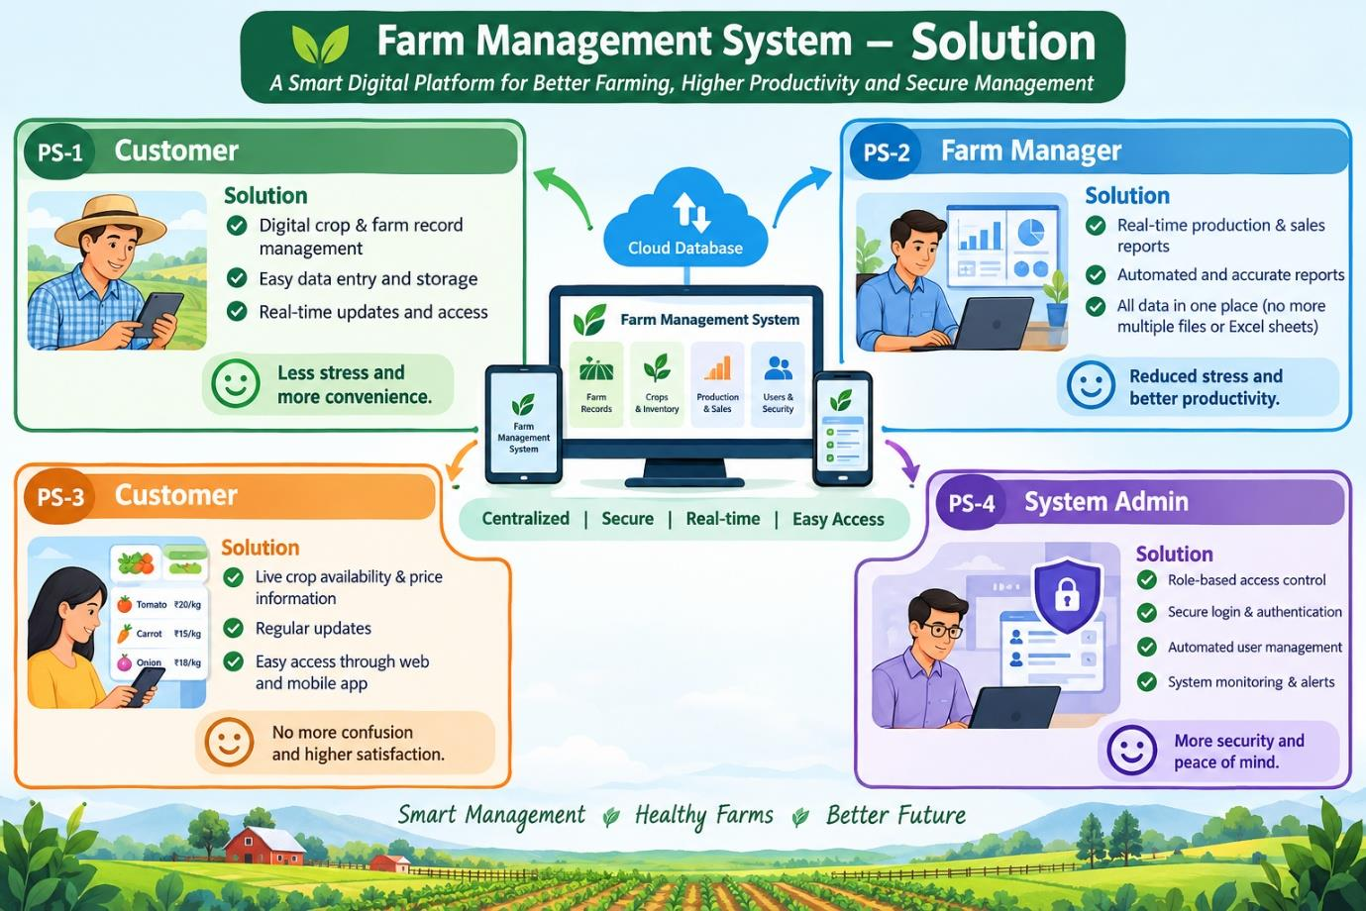
Figure 1: Project screenshot or diagram

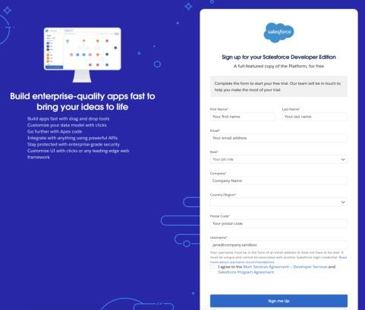
Figure 7: Project screenshot or diagram
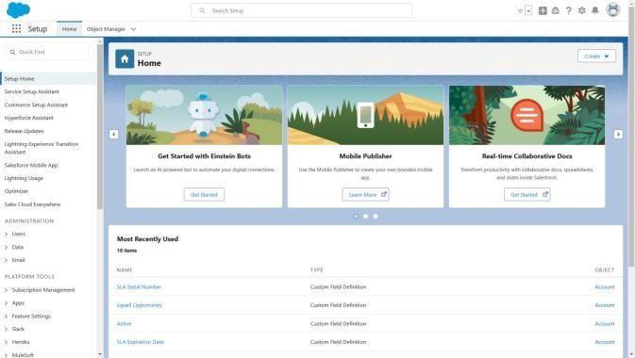
Figure 8: Project screenshot or diagram
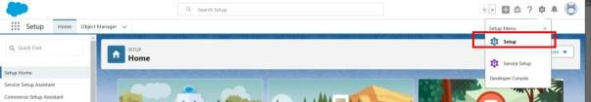
Figure 9: Project screenshot or diagram
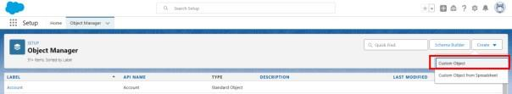
Figure 10: Project screenshot or diagram
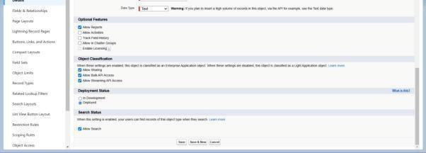
Figure 11: Project screenshot or diagram

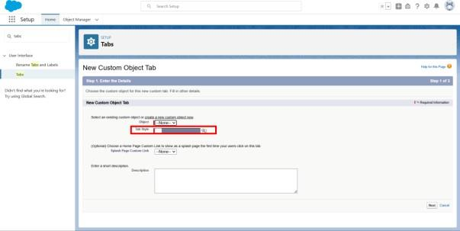
Figure 14: Project screenshot or diagram
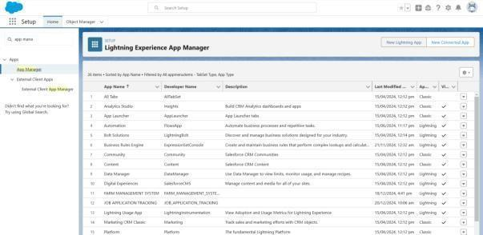
Figure 15: Project screenshot or diagram
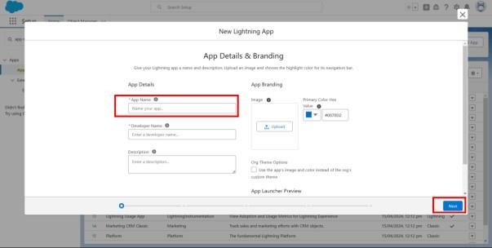
Figure 16: Project screenshot or diagram
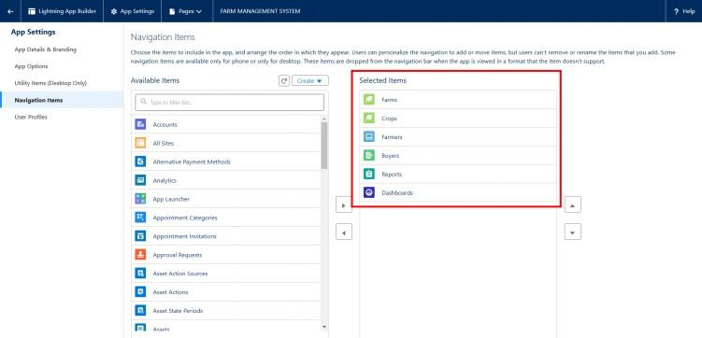
Figure 17: Project screenshot or diagram
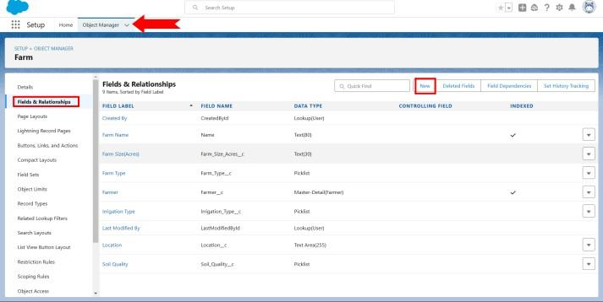
Figure 18: Project screenshot or diagram
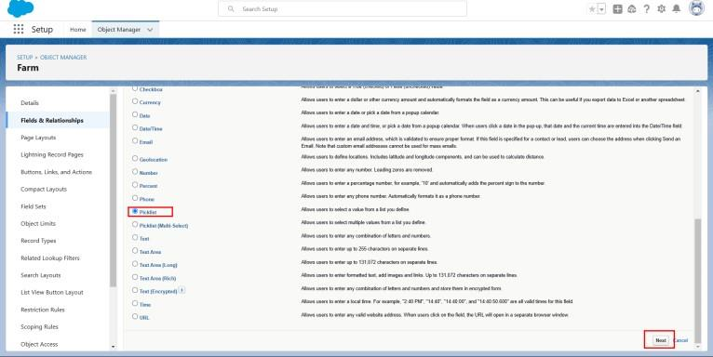
Figure 19: Project screenshot or diagram
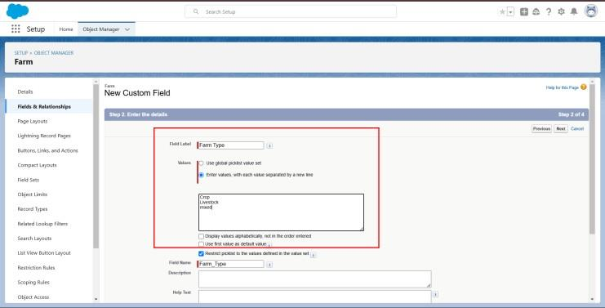
Figure 20: Project screenshot or diagram
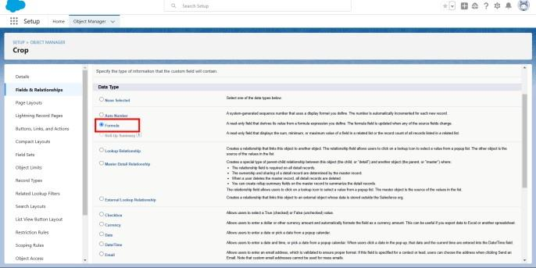
Figure 21: Project screenshot or diagram
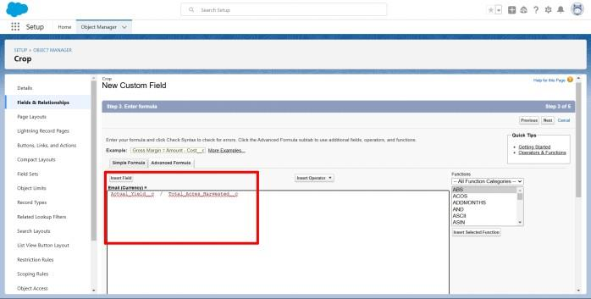
Figure 22: Project screenshot or diagram
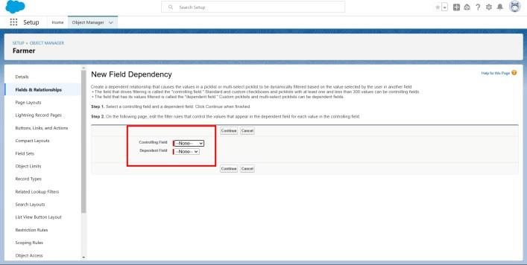
Figure 23: Project screenshot or diagram
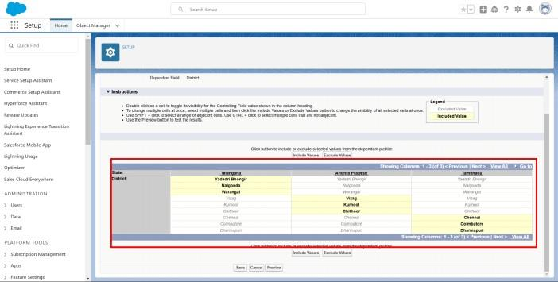
Figure 24: Project screenshot or diagram
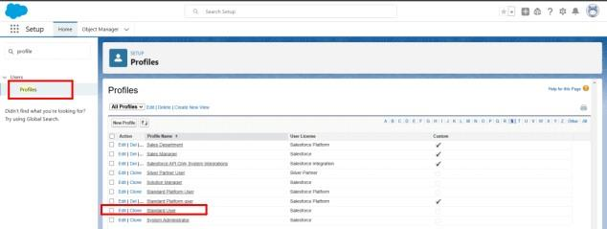
Figure 25: Project screenshot or diagram
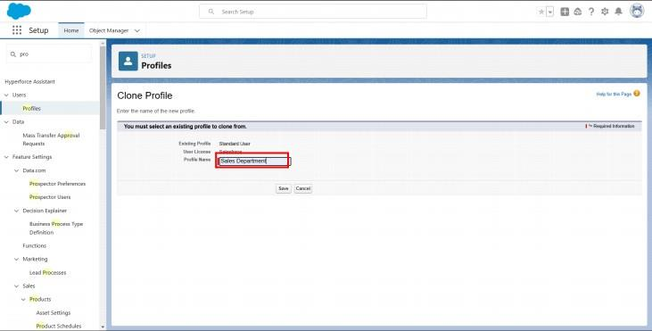
Figure 26: Project screenshot or diagram
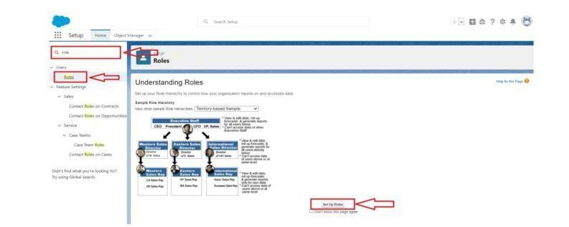
Figure 27: Project screenshot or diagram
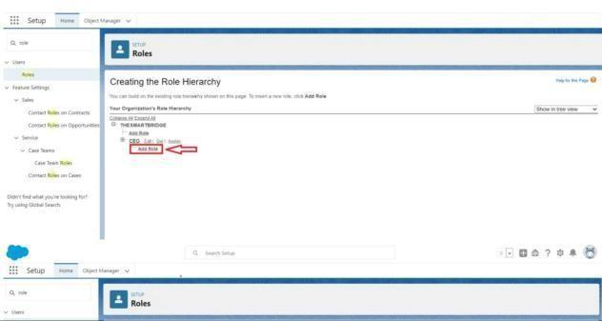
Figure 28: Project screenshot or diagram
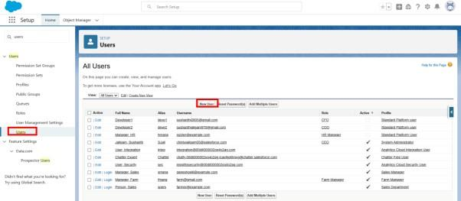
Figure 29: Project screenshot or diagram
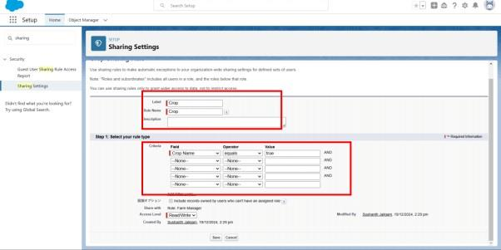
Figure 30: Project screenshot or diagram
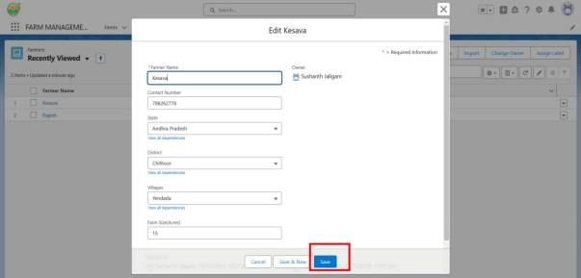
Figure 31: Project screenshot or diagram
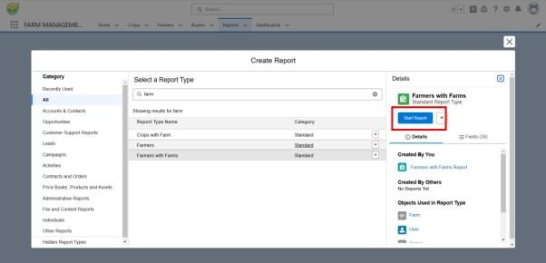
Figure 32: Project screenshot or diagram
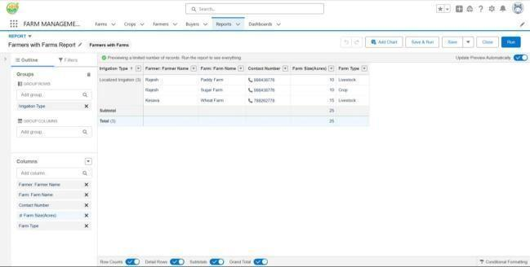
Figure 33: Project screenshot or diagram
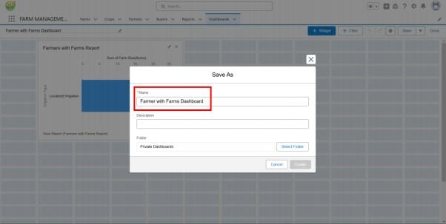
Figure 34: Project screenshot or diagram
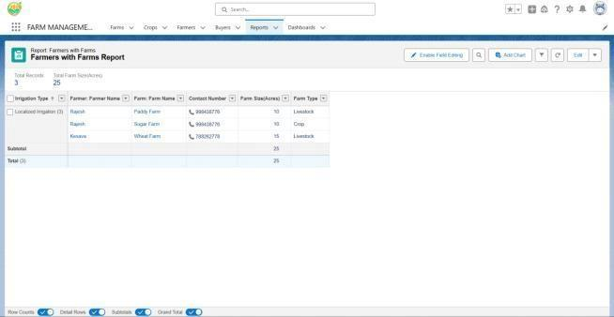
Figure 35: Project screenshot or diagram
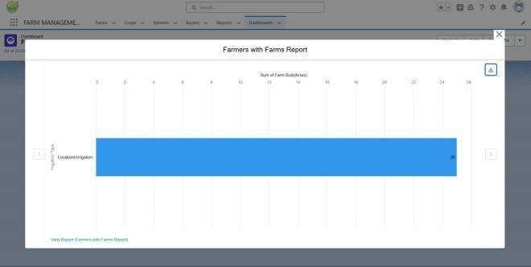
Figure 36: Project screenshot or diagram

